MAJOR PROJECT
End-to-End Analytics Case Study — Olist
iNeuBytes VIIP — Data Analyst Internship

Intern Name | Devpal Singh Anand
Regd No | INBT019627
Course ID | DAINB20626
Education | BCA · MCA Cyber Security
Dataset | Olist Brazilian E-Commerce (olist.db)

1. Business Problem
Problem: I wanted to understand where the revenue was concentrated, which product categories were driving it, and how delivery performance was affecting customer reviews.
Data: Olist Brazilian E-Commerce, 96,478 orders, 9 tables, 2016-2018.

2. ETL & Data Preparation
- Extract: 9 CSVs → SQLite
- Transform: 655 missing values, text, dates
- Load: Excel, Power BI, Tableau
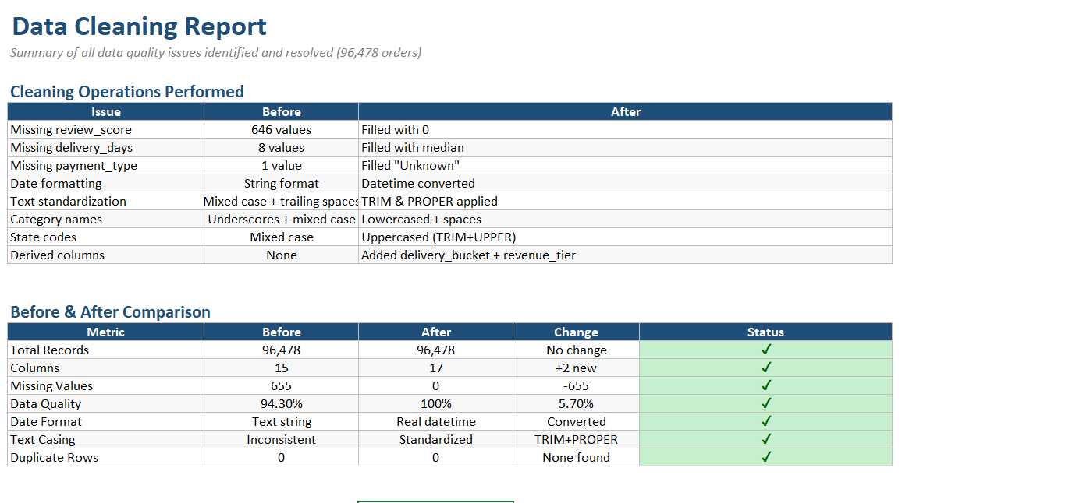
📸 Data Cleaning Report

3. Exploratory Analytics
- Revenue: R$13.6M, AOV: R$137.75, 96,478 orders
- SP = 38%, top 3 = 63%
- Peak: Nov 2017 (Black Friday)
- 3.12% repeat rate
- 91.89% on-time, 12.6-day avg

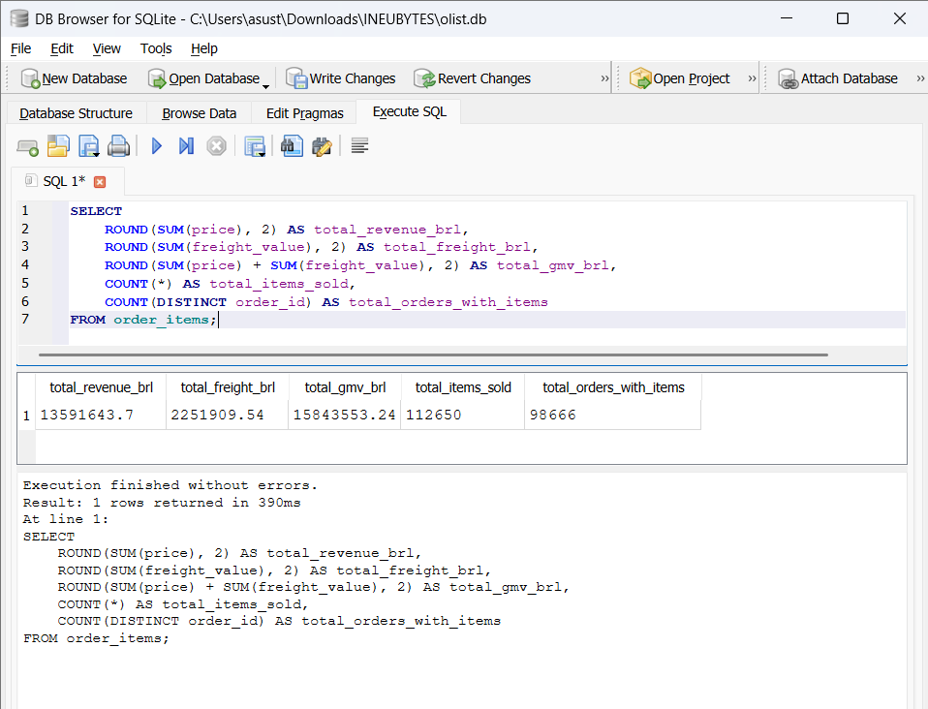
📸 Total Revenue
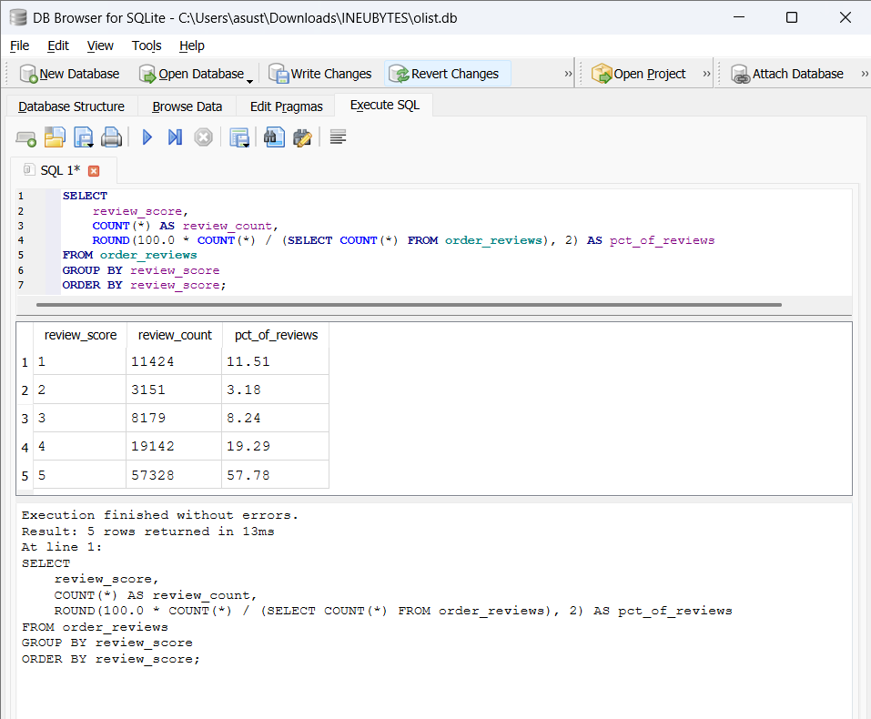
📸 Review Distribution

4. Advanced Analytics
4.1 A/B Testing
0-7 days: 4.42★ vs 22+ days: 3.12★ — significant difference.
4.2 Forecasting
Monthly revenue expected to stabilize at R$900k-1M.
5. Dashboards
- Excel: 6 KPIs + 6 charts
- Power BI: KPI + combo + map + slicers
- Tableau: 2 dashboards

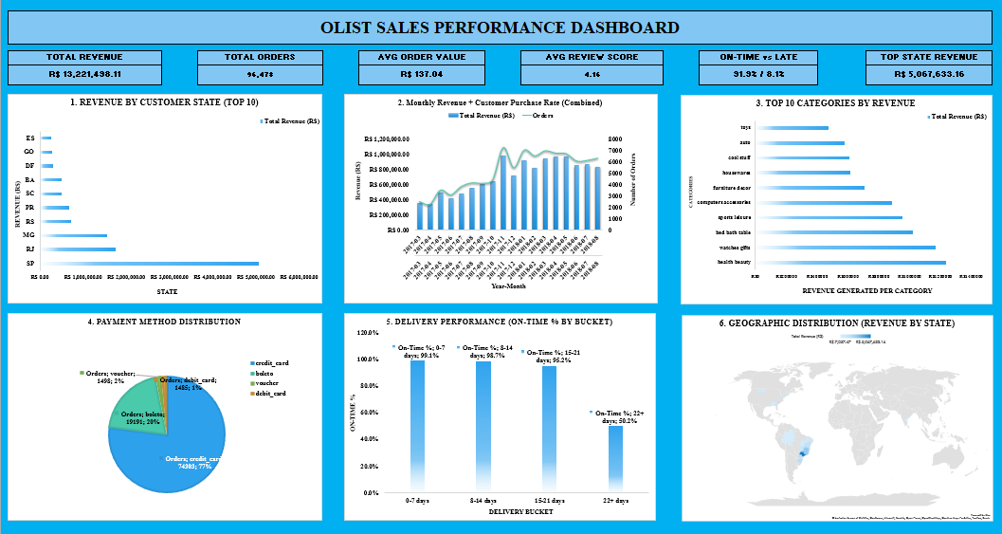
📸 Excel Dashboard

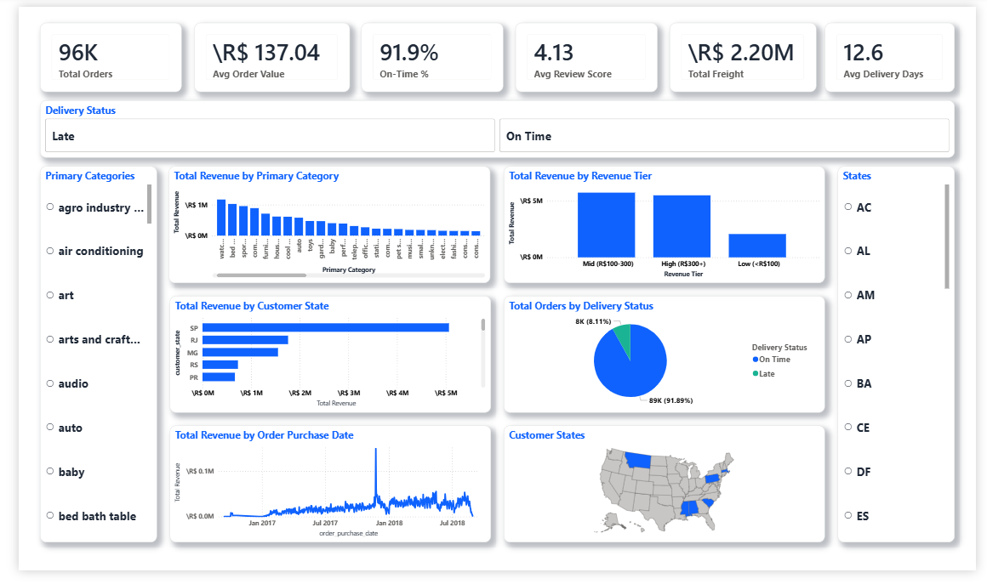
📸 Power BI Dashboard
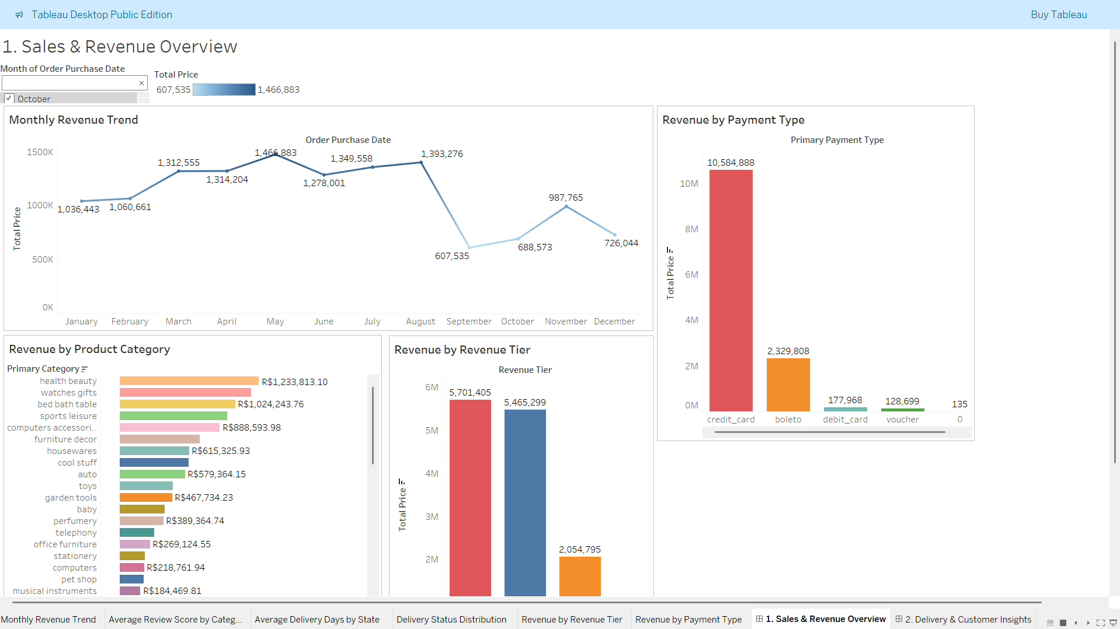
📸 Tableau Dashboard 1

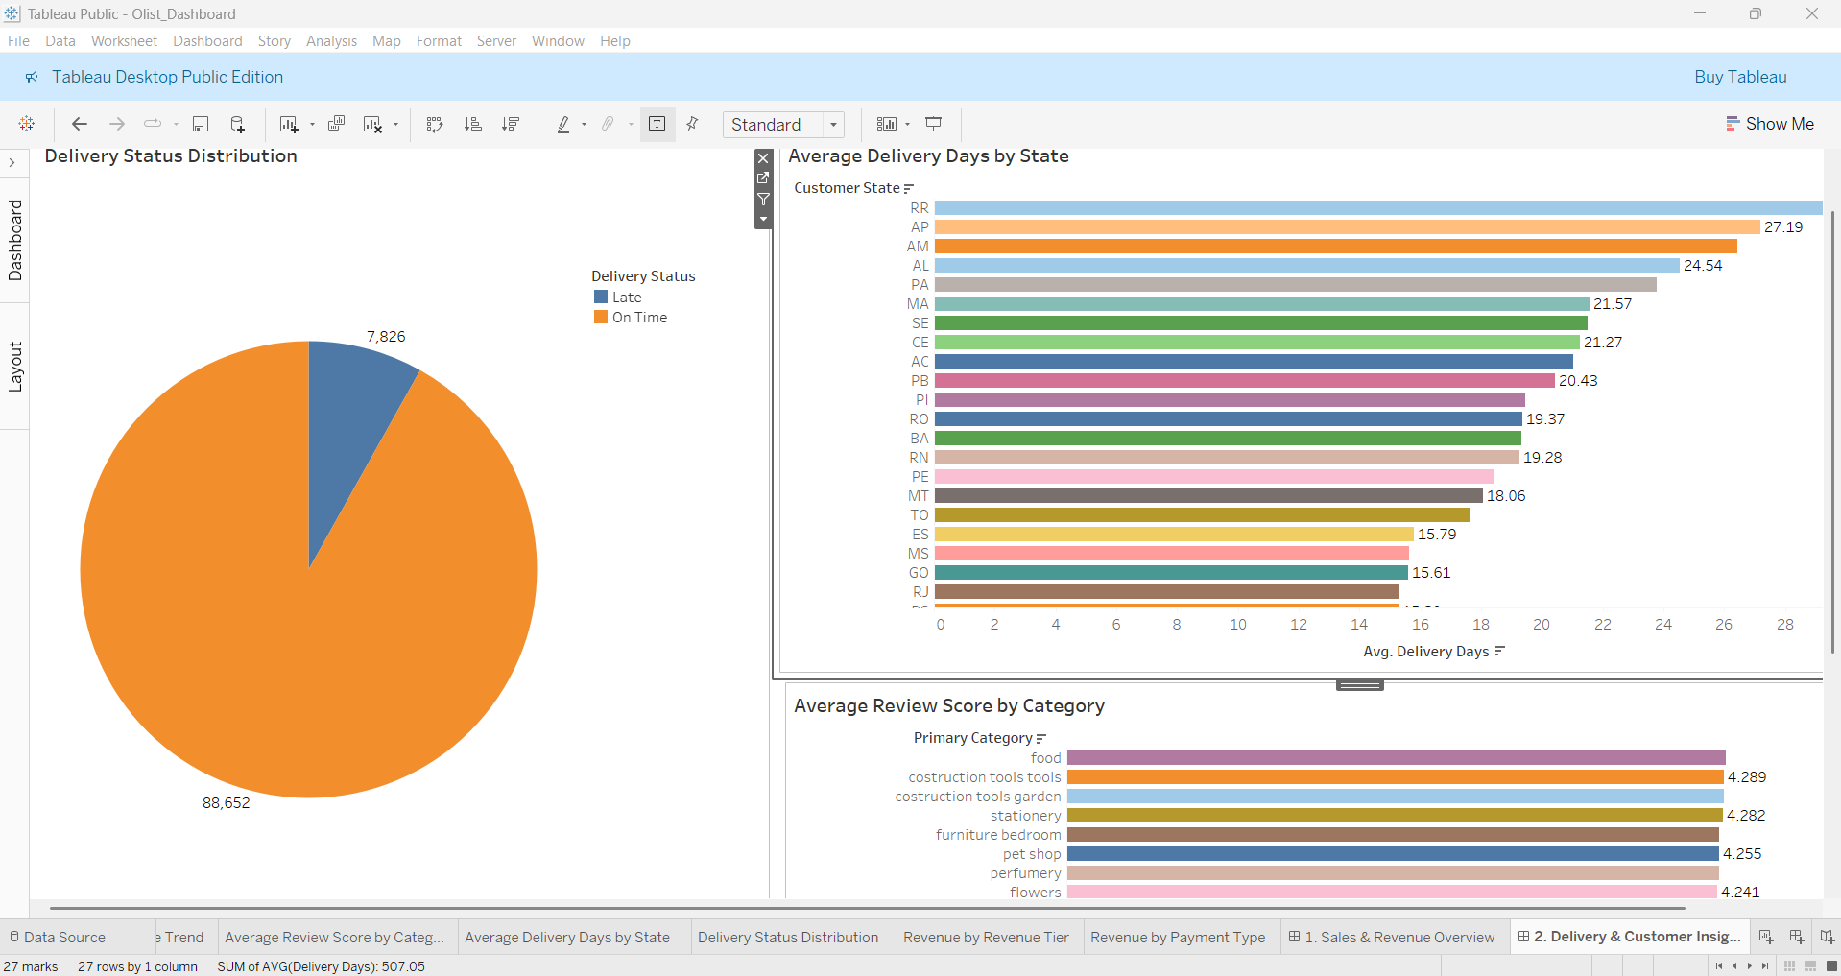
📸 Tableau Dashboard 2

6. Recommendations
# | Recommendation | Impact
1 | Diversify geography | SP 38% → 30%
2 | Fast delivery | Reviews 4.09 → 4.3+
3 | Retention program | Repeat 3.1% → 8%+
4 | Maintain installments | Protect 67% CC conversion
5 | Top 25% product categories | 79% of revenue

7. Tools & Techniques
Tool | Purpose | Techniques
SQLite | SQL analysis | Joins, window functions, CTEs
Excel | Dashboard | SUMIFS, VLOOKUP, pivots
Power BI | BI dashboard | DAX, star schema, maps
Tableau | BI dashboard | Calculated fields, filters

8. Key Metrics
Metric | Value
Total Revenue | R$ 13,591,643.70
Total Orders | 96,478
AOV | R$ 137.75
Customers | 96,096
Repeat Rate | 3.12%
Avg Review | 4.09/5.0
On-Time | 91.89%
Avg Delivery | 12.6 days

9. Problems Identified
Looking a little deeper into the data — especially the state-wise distribution, category-wise distribution, and the unusual spike in one month — reveals a few patterns that aren’t obvious from the summary statistics alone. These patterns also give some possible reasons for why the data is distributed this way.
9.1 State-Wise Concentration
São Paulo alone accounts for 38% of orders, and the top 3 states together make up 63%. A few factors could be contributing to this concentration, although it’s difficult to say which one has the biggest impact without more regional data.
- Population and income density in SP, RJ, and MG could explain a large part of this. These are among Brazil’s most developed states and likely have a much larger base of online shoppers.
- Seller and fulfillment infrastructure is also heavily concentrated in the Southeast. Orders within the region can be fulfilled faster and at lower delivery costs, which could be reinforcing the concentration rather than simply reflecting existing demand.
- Weaker digital and courier infrastructure in the North and Northeast could be limiting both demand and delivery reliability. The difference in delivery times makes this a possibility worth looking into.
- The 12.6-day average delivery time also seems to hide a regional difference. Southeast orders may be coming in well below the overall average, while orders going further out could be taking considerably longer. The state-level breakdown in the additional dashboard findings shows this more clearly.
- This concentration also makes total revenue more exposed to any disruption in the major states. That is likely what Recommendation #1 — diversifying the geography from SP 38% toward 30% — is trying to address.
- Closing this gap looks more like a fulfillment problem than a marketing problem. Regional distribution points or local carrier partnerships seem like a more direct way to address it than simply increasing ad spend.

9.2 Why the Top Categories Dominate?
The leading product categories generate roughly 79% of total revenue. A few factors could explain why these categories are so far ahead of the rest.
- Everyday, low-consideration categories such as bed/bath/table, health & beauty, and sports/leisure probably sell in higher volumes because they cover recurring needs rather than one-time purchases.
- There may also be a visibility effect. Categories with more sellers and listings are likely to appear more often in search and recommendations, which can push even more sales toward categories that are already performing well.
- Price point could be another factor. Products priced around the R$137.75 average order value are easier to purchase, and they also fit well with the platform's strong use of installment payments.
- Reviews can reinforce the same pattern. The top categories naturally collect reviews faster, which reduces the perceived risk for new buyers and can help maintain higher conversion.
- Shipping is another possible factor. Standard-sized, mid-range products are generally easier and more predictable to ship, which could be helping these categories maintain better delivery performance and customer ratings.
- The main concern is the level of dependence this creates. If revenue becomes even more concentrated in the same categories, a drop in one or two of them could have a much larger impact on total revenue. This is worth monitoring alongside the state-level concentration.

9.3 Why November 2017 Peaked?
Monthly revenue spiked sharply in November 2017 relative to every other month.
- Black Friday timing is by far the most likely explanation. It fell within this month, and the event usually leads to a large increase in discretionary spending.
- Platform-wide promotions and seller discounting around the event probably pulled purchases forward that would otherwise have happened later in Q4, or may not have happened at all.
- Search and marketing activity likely increased in the run-up as well. This could explain why the spike came from both higher traffic and better conversion, rather than simply larger basket sizes.
- The forecasted stabilization around R$900k–1M per month most likely reflects a return to normal levels after this one-off peak rather than a genuine decline in underlying demand. The post-August pattern is another factor worth considering here.
- Operationally, a spike this concentrated probably puts pressure on seller stock and courier capacity at the same time. That also fits with delivery performance becoming harder to maintain around major sales events.
- Since the peak is calendar-driven and repeatable, it looks like something that can be planned for. Preparing stock, staffing, and logistics ahead of the event seems like a more realistic strategy than treating the spike as a surprise every year.
10. Additional Problems that were Identified
Going back through the Excel, Power BI, and Tableau dashboards revealed a few additional patterns that were not part of the three main problem statements. These findings point toward areas that could affect customer experience, operations, and overall business performance.
- The 1-star review spike. Review scores are not spread evenly across the 1–5 range. 1-star reviews account for 11.51%, compared with 3.18% for 2-star and 8.24% for 3-star reviews. The unusually high 1-star share suggests that some customers may be facing more serious issues, such as non-delivery, wrong items, or damaged products, although the available data does not confirm the exact cause.
- The 22-day delivery cliff. On-time delivery stays around 95–99% for the 0–7, 8–14, and 15–21 day groups, but drops sharply to 50.2% once delivery goes beyond 22 days. This sudden change suggests that orders taking more than 22 days may be facing a different operational issue, such as lost shipments, regional handoffs, or last-mile problems.
- The state-level delivery gap. Average delivery time varies significantly between states, from around 7–8 days in São Paulo and Rio de Janeiro to more than 27 days in Amapá and more than 24 days in Alagoas. The overall 12.6-day average therefore hides a much wider regional difference. Distance, carrier coverage, and last-mile infrastructure could all be contributing factors.
- The post-August revenue decline. Monthly revenue rises through much of the year before falling sharply after August, from roughly R$1.39M to R$0.61M. This could indicate a drop in demand, but there is also a possibility that the later part of the dataset is incomplete. The raw order timestamps should be checked before treating this as a genuine business trend.
- Payment-method concentration. Credit card usage appears to account for roughly 77–81% of orders and revenue, while debit card and voucher payments together represent less than 2%. This makes the credit-card channel particularly important for payment and installment-related decisions.
- Revenue-tier differences. The Mid (R$100–300) and High (R$300+) order-value groups appear relatively close, while the Low (<R$100) group contributes less. This difference could be useful when considering minimum-order thresholds, free-shipping policies, and how support or operational resources are allocated.
- Niche categories with stronger reviews. Smaller categories such as food, construction tools, and stationery show higher average review scores than several of the top-revenue categories. Their lower volumes mean they are unlikely to change overall satisfaction by themselves, but they could still provide useful insights when looking at seller quality and customer experience.
11. Conclusion
The analysis of the Olist Brazilian E-Commerce dataset shows strong overall activity, with 96,478 orders generating R$13,591,643.70 in revenue. However, the deeper analysis shows that the business is not growing evenly. Orders and revenue are concentrated across a smaller number of states and product categories, while the November 2017 spike shows how seasonal demand can further amplify these patterns.
The additional findings from Excel, Power BI, and Tableau also show that the overall averages hide some important differences. The 1-star review share, the sharp delivery-performance drop after 22 days, the state-level delivery gap, payment-method concentration, and the revenue decline after August all point toward areas that need closer attention. Some explanations, such as the Black Friday effect and possible data incompleteness after August, should still be validated with additional data rather than treated as confirmed causes.
Overall, the main opportunity is not simply to increase sales, but to make growth more balanced and reliable. Reducing dependence on a few regions and categories, improving delivery performance, and strengthening customer retention can make the business more resilient. The analysis therefore provides a clear view of where Olist is performing well, where the major risks are concentrated, and which areas can be targeted for further improvement.

